WHAT IS MARSHFIELD COMMUNITY LAND TRUST LTD
A local Community Benefit Society
Not for profit
Open to all (currently 180 members)
Democratically accountable to our members
Supported by Marshfield Parish Council and South Glos. Council

WHAT WE BELIEVE IN
Collective action for community benefit
Working towards net zero
Partnership working with other organisations (local and national)
Small scale, community led development

CURRENT PRIORITIES
Affordable housing for local people (focus on social housing)
Locally generated energy and local energy conservation

WHY COMMUNITY LED?
Encourages self-determination and responsive to local identified needs
Helps build a resilient, diverse and enterprising local community

WHO'S WHO?
MCLT Board members are:
Christine Eden – Chair, christine.eden@marshfieldclt.org
Oliver Shirley -Vice Chair, John Fuller – Secretary
Simon Turner – Treasurer, Ian Dawes, Ian Jones, Jim Brookes, Ros Snow, Caroline Page, Simon Pressdee

* Marshfield Community Land Trust Ltd is Registered with the Financial Conduct Authority ( 7361)
Registered under the Cooperative Benefits Societies Act 2014.
Registered Office, Tolzey Hall, 41 High Street, Marshfield SN14 8LR
CURRENT HOUSING SCHEME- Wheatfield Barns
In partnership with Brighter Places
Constructed by Winsley White Contractors Ltd
10 house social rent
5 shared ownership
Occupation Sept/October

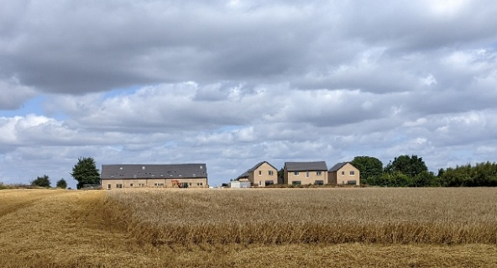

ENERGY PROJECT
Awaiting new government policy that supports community energy to identify implications for MCLT scheme

WHAT NEXT
Finish Wheatfield Barns housing project
Research the need for a second community-led, local housing project
SGC Local Plan: Final draft backs no allocation to Marshfield and supports community-led housing and role of MCLT
Continue to develop the local energy project
Review other important community needs

